**新人教PEP六年级上英语Unit4 I have a pen pal 第2课时**

**试题 A Let’s learn&Do a survey**



1. 写出下列单词的-ing形式。

Sing __________ do __________



dance __________ swim ________

jog ____________ read ________

exercise ________ read ________

shop ___________ run _________

play ___________



1. 连线。
2. 骑自行车 A.play the pipa
3. 制作风筝 B.ride a bike
4. 读故事 C.do kung fu



1. 练功夫 D.read stories
2. 弹琵琶 E.make kites
3. 连线。
4. I like A.read stories together.



1. He often B.together
2. We usually C.goes to school by bikes
3. Let’s go D.to watch TV
4. I want E. playing football
5. 连词成句。
6. you us can with go ?

_________________________________

1. like also singing kung fu doing and I .



_____________________________________

1. what your are hobbies ?

_______________________________________

1. go let’s together .

_________________________________________

1. and he singing dancing likes .

______________________________________

1. have I friend a .

_______________________________________



1. too he stories reading likes .[来源:学科网]

________________________________________-

1. like to I music listening .

______________________________________

1. 翻译。
2. 你有什么业余爱好？



_______________________________________

1. 我喜欢唱歌和跳舞。

_______________________________________[来源:学科网ZXXK]

1. 我也喜欢唱歌和练功夫。

————————————————————

[来源:学科网]

三．

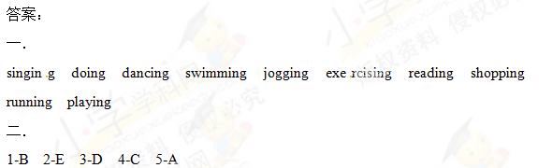

1-E 2-C 3-A 4-B 5-D

四．

1. Can you go with us ?[来源:学§科§网]

2. I also like singing and doing kung fu.



3. What are your hobbies ?

4. Let’s go together.[来源:Zxxk.Com]

5. He likes singing and dancing.

6. I have a friend.

7. He likes reading stories,too.



8. I like listening to music.

五．

1. What are your hobbies ?

2. I like singing and dancing.



3. I also like singing and doing kung fu./

I like singing and doing kung fu,too.